Traveller 5

Kakadan (Vland)

maggot..iiss@sky.com

Subsector guide

General Details for Imperial Forces

5FW style System box.

T4 Imperial Squadrons & Captains.

T4 Pocket Empires & Troops.

T5 System maps.

Links to relevant data online.

PLACES TO VISIT:
PLACES TO AVOID:
KNOWN FRIENDLY AREAS:
KNOWN HOT SPOTS:
KNOWN PERSONNEL:

BLANK CAMPAIGN FORMS :

Imperial Fleet Presences & Marines for all surrounding subsectors

Traveller 5

Kakadan (Vland)

maggot..iiss@sky.com

Noblesse Oblige

Obligations of Nobility

5FW style System box.

T4 Imperial Squadrons & Captains.

T4 Pocket Empires Troops.

T5 System maps.

Links to relevant data online.

PLACES TO VISIT:
PLACES TO AVOID:
KNOWN FRIENDLY AREAS:
KNOWN HOT SPOTS:
KNOWN PERSONNEL:

BLANK CAMPAIGN FORMS :

Imperial Fleet Presences & Marines for all surrounding subsectors

R U Ready 4 WAR? - Indispensable Notebook
Imperial Naval Intelligence for Travellers.
5FW style System box.
T4 Imperial Squadrons & Commodores.
T4 Pocket Empires Troops.
T5 System maps.
Links to relevant data online.
Collated into a PDF with 1 System per sheet of print
Does not contain rules:
but 5FW, IE, IS, PE or any other should work.
Mark Ferguson
maggot.iiss@sky.com
https://github.com/MaggotIISS
Saarpuhii
Engegueklii Agushdakemgam (Call me Klii)
Duke of Kesali (Vland/2737)
Starring - Walter the Wobot!
(with a lithp - Dukes' Butler)

Marx Sagaa (a.k.a. Markii)
Baron of Fraynj (Gushmege/1623)

Tracii
#11, Chief of Supply (Lt.Cmdr.),
BCF Shurduu,
154th BRS

Debii
#104, Executive Officer (Lt.Cmdr.),
BR Galek,
154th BRS

Fergii
#88, Troop Commander (Captain O3), Delta Troop (Lift Cavalry)
5th Squadron (Lift Cavalry), 4518th LIR,
MCG The Final Victory At Uakye

Jimii
#279, Platoon Leader (Lt. O2), 3rd Platoon, Delta Troop (Lift Cavalry),
5th Squadron (Lif Cavalry), 4518th LIR
MCG Battle of Mongo

Iggii (Vargr)
TAS Member OF Galis (Delphi/0918) NOT FROM!

Kakadan Subsector (Vland)
Neighbours
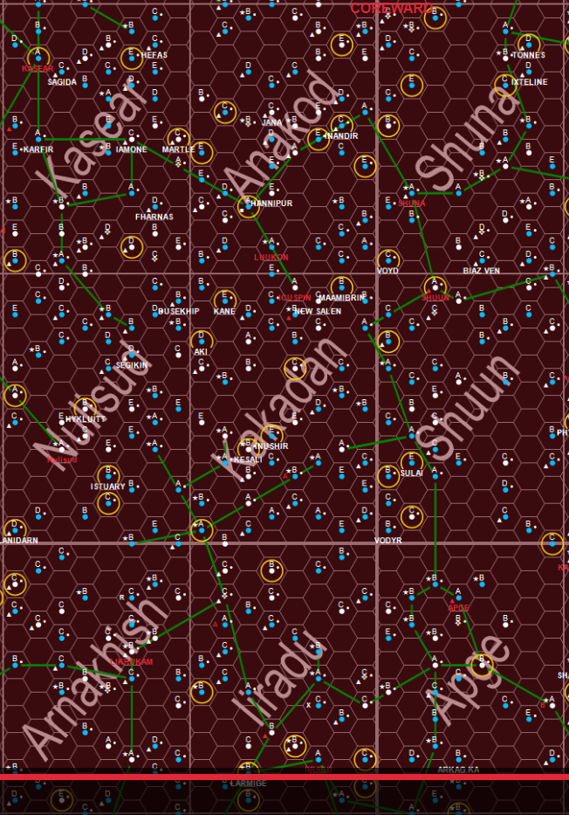

Kakadan Subsector (Vland)
CapitalCandidates
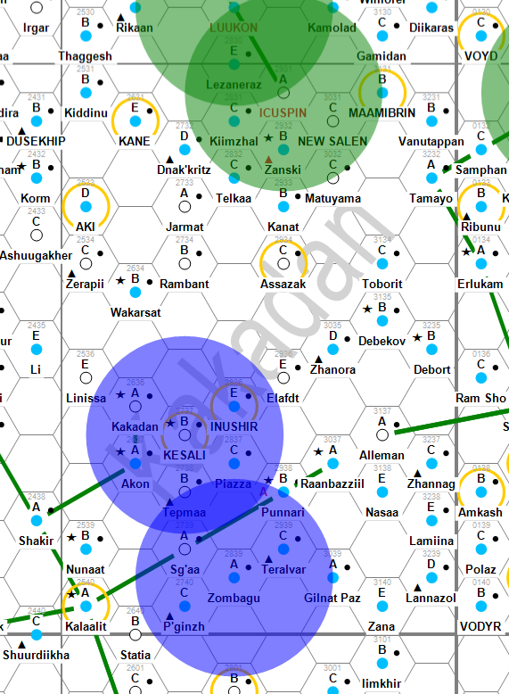

Kakadan Subsector (Vland)
DroyneWorlds
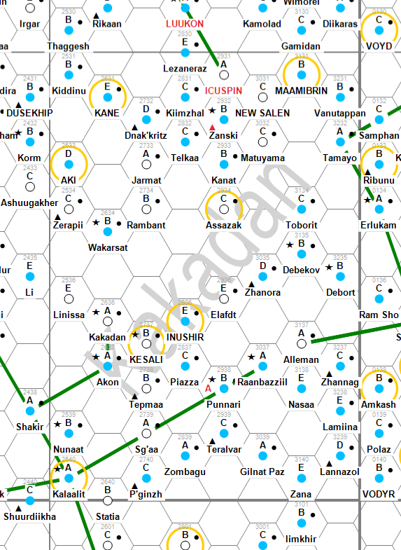

Kakadan Subsector (Vland)
Importance
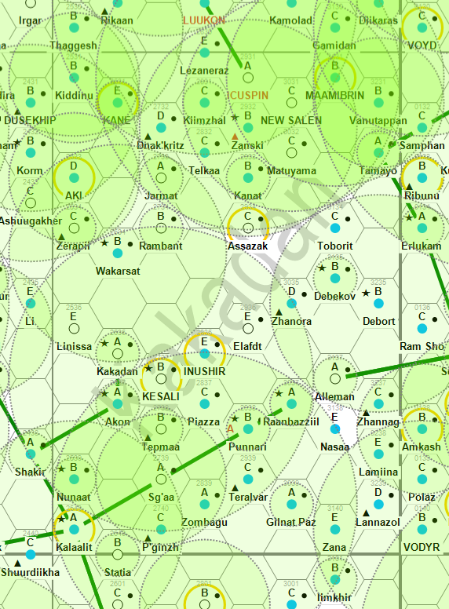

Kakadan Subsector (Vland)
Minor Races
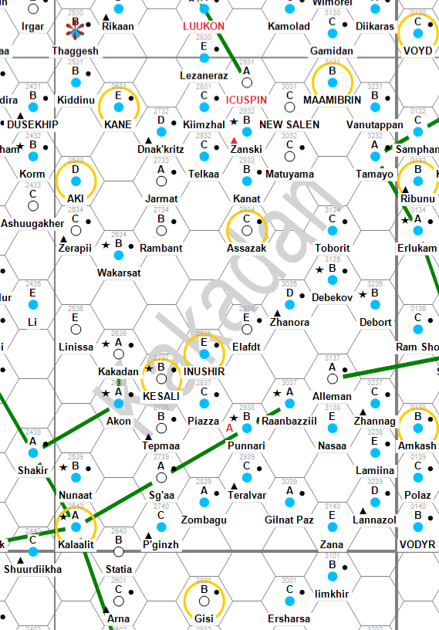

Kakadan Subsector (Vland)
Population
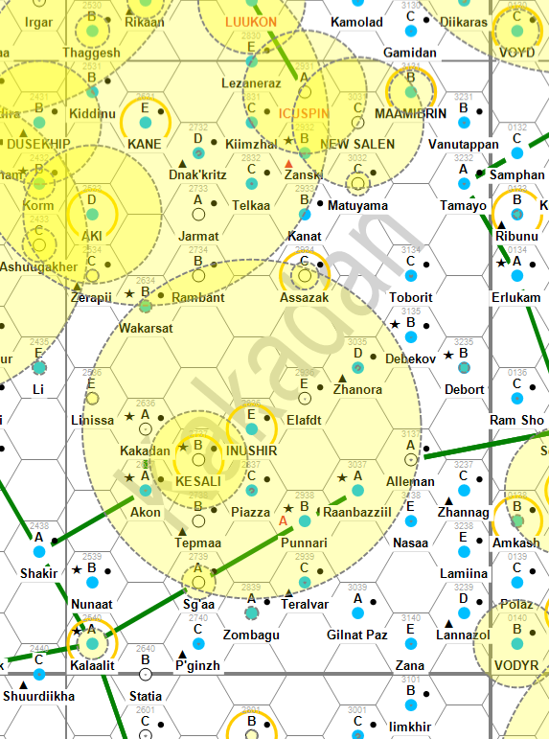

Kakadan Subsector (Vland)
Stellar View
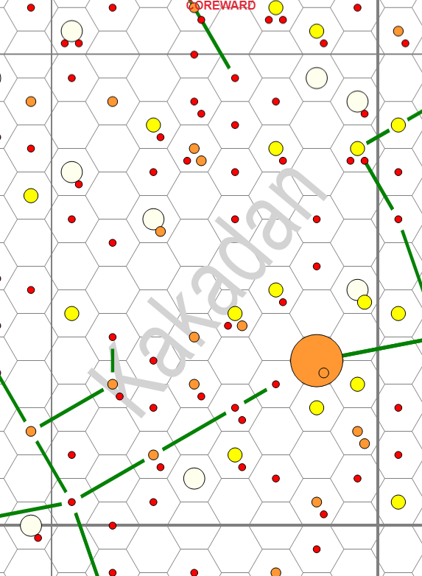

Vland Sector
Sector J1-Main
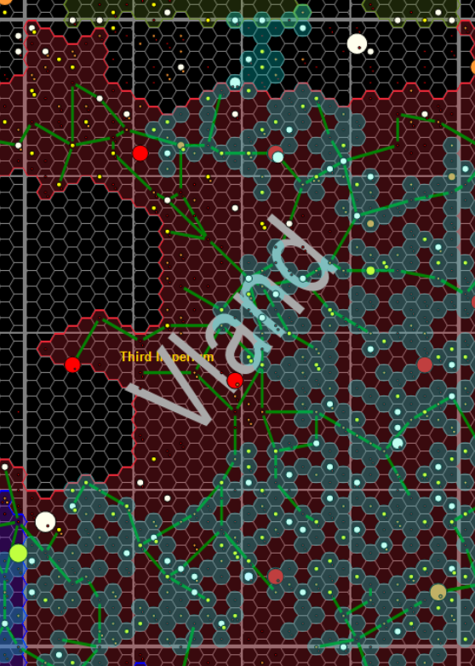

Kakadan Subsector (Vland)
MainWorlds
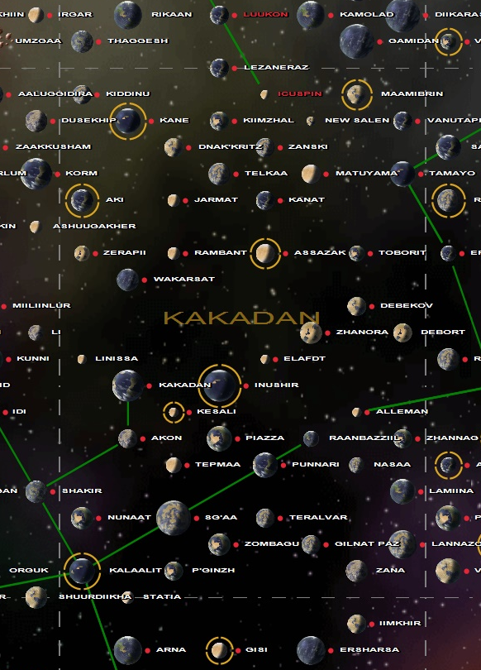

Vilani Campaign Recon (VCR) Books 0-8

----------
1=K 2=L 3=I
8=0 0=P 4=M
7=C 6=D 5=A
----------

Book 0: Kakadan subsector (Vland)
https://drive.google.com/open?id=1aAV6isJiLGGeG9OBR0M17YEb7rXtf0Je
https://github.com/MaggotIISS/T5/blob/master/Vland/P%20Kakadan/Kakadan%20Subsector.pdf

Book 1: Kasear subsector (Vland)
https://drive.google.com/open?id=1JgoXHkF4ZHH5IITpsiAXIKe_tMIAozDP
https://github.com/MaggotIISS/T5/blob/master/Vland/K%20Kasear/Kasear%20Subsector.pdf

Book 2: Anakod subsector (Vland)
https://drive.google.com/open?id=1pMGWm3T1jd4Mq9iGNKsfv5aL9B6LbzXv
https://github.com/MaggotIISS/T5/blob/master/Vland/L%20Anakod/Anakod%20Subsector.pdf

Book 3: Shuna subsector (Lishun)
https://drive.google.com/open?id=1HeCCkLPfCPxaYz88ccLh_zZbChRWy8pt
https://github.com/MaggotIISS/T5/blob/master/Lishun/I%20Shuna/Shuna%20Subsector.pdf

Book 4: Shuun subsector (Lishun)
https://drive.google.com/open?id=1bE6Vnx9rJqupc6Ru6aPVbDRxUIrUvWsd
https://github.com/MaggotIISS/T5/blob/master/Lishun/M%20Shuun/Shuun%20Subsector.pdf

Book 5: Apge subsector (Core)
https://drive.google.com/open?id=1ns1HtpknAH1V0xrjgK5QFmGjOXc73PKx
https://github.com/MaggotIISS/T5/blob/master/Core/A%20Apge/Apge%20Subsector.pdf

Book 6: Iiradu subsector (Dagudashaag)

Book 7: Arnakhish subsector (Dagudashaag)

Book 8: Nulisud subsector (Vland)
https://drive.google.com/open?id=14Hh7LO4DBmZTN8CuJu-002C8PgGo3WuK
https://github.com/MaggotIISS/T5/blob/master/Vland/O%20Nulisud/Nulisud%20Subsector.pdf

WORK IN PROGRESS!!



ORBIT PATHS
Red = Inner: Gress = Habitable: Blue = Outer
Pink Bar = 10D Blue Bar = 100 D Grey Bar = 1000D

5FW STYLE SYSTEM BOX
Outer Box = TAS zone
Inner Box = Atmosphere
Green Circle = Size
Blue Circle = Hydrographics

TRAVELLER WIKI ASSISTANCE

----------
1=K 2=L 3=I
8=0 0=P 4=M
7=C 6=D 5=A
----------

KAKADAN SUBSECTOR AND NEIGHBOURS
0 = P Kakadan/Vland
http://wiki.travellerrpg.com/Kakadan_Subsector
C:\T5\Vland\P Kakadan

1 = K Kasear/Vland
http://wiki.travellerrpg.com/Kasear_Subsector
C:\T5\Vland\K Kasear

2 = L Anakod/Vland
http://wiki.travellerrpg.com/Anakod_Subsector
C:\T5\Vland\L Anakod

3 = I Shuna/Lishun
http://wiki.travellerrpg.com/Shuna_Subsector
C:\T5\Lishun\I Shuna

4 = M Shuun/Lishun
http://wiki.travellerrpg.com/Shuun_Subsector
C:\T5\Lishun\M Shuun

5 = A Apge/Core
http://wiki.travellerrpg.com/Apge_Subsector
C:\T5\Core\A Apge

6 = D Iiradu/Dagudashaag
http://wiki.travellerrpg.com/Iiradu_Subsector
C:\T5\Dagudashaag\D Iiradu

7 = C Arnakhish/Dagudashaag
http://wiki.travellerrpg.com/Arnakhish_Subsector
C:\T5\Dagudashaag\C Arnakhish

8 = O Nulisud/Vland
http://wiki.travellerrpg.com/Nulisud_Subsector
C:\T5\Vland\O Nulisud

Gushemege Sector
http://wiki.travellerrpg.com/Gushemege_Sector
Sallounn Subsector
http://wiki.travellerrpg.com/Sallounn_Subsector
Fraynj (world)
http://wiki.travellerrpg.com/Fraynj_(world)
Domain of Vland
http://wiki.travellerrpg.com/Domain_of_Vland

Vland Sector
http://wiki.travellerrpg.com/Vland_Sector
Kakadan Subsector
http://wiki.travellerrpg.com/Kakadan_Subsector
Kesali (world)
http://wiki.travellerrpg.com/Kesali_(world)
Duke of Kesali (Vilani - Solomani mix)

OTHER LINKS

Dating Systems, Unified Timeline
http://members.tip.net.au/~davidjw/libdata/alphabet/v/vilani.htm

Argushiigi Admegulasha Bilanidin
http://members.tip.net.au/~davidjw/libdata/



Commodore Fergiison
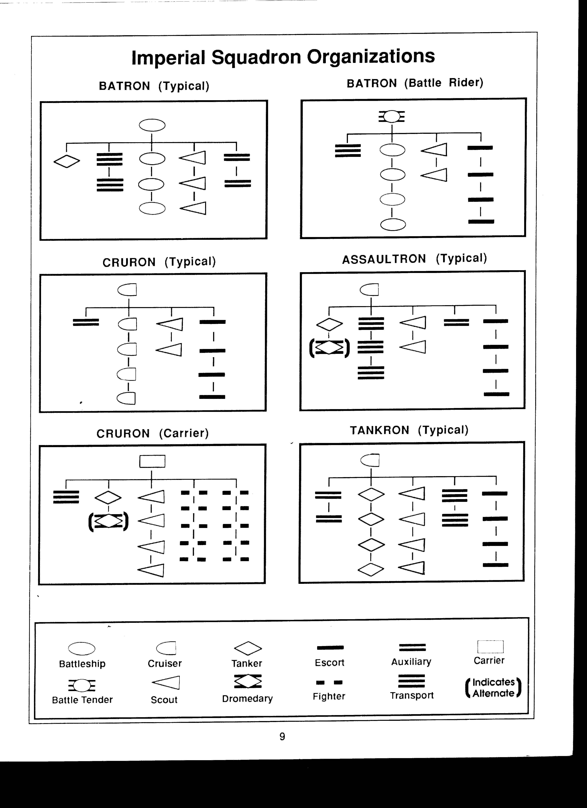

Commodore Fergiison

Kakadan Subsector (Vland)

https://drive.google.com/open?id=1bxPmscrN_sflqzEt8-L3PTIw9Dh0tr8M

https://travellermap.com/?x=-5.629&y=43.5&scale=64&options=58363
The Traveller game in all forms is owned by Far Future Enterprises.
Copyright 1977 - 2018 Far Future Enterprises.
Traveller is a registered trademark of Far Future Enterprises.
Far Future permits web sites and fanzines for this game, provided it contains this notice, that Far Future is notified, and subject to a withdrawal of permission on 90 days notice.
The contents of this site are for personal, non-commercial use only. Any use of Far Future Enterprises's copyrighted material or trademarks anywhere on this web site and its files should not be viewed as a challenge to those copyrights or trademarks. In addition, any program/articles/file on this site cannot be republished or distributed without the consent of the author who contributed it

Sweeter after difficulties
Nihil verum nisi mors
Only Death is Real!

